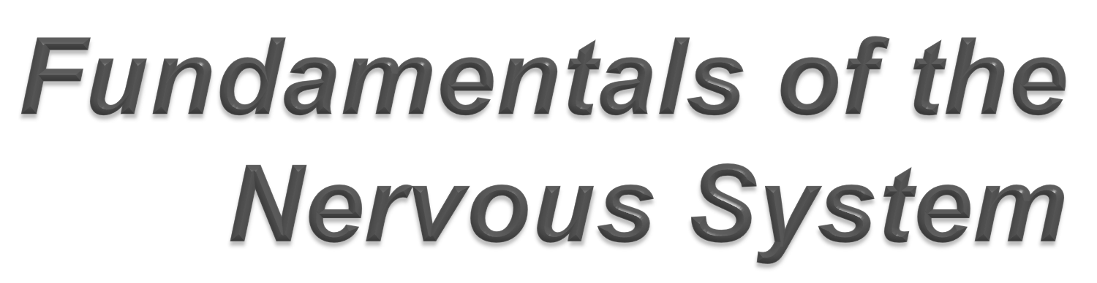

Presented by Payal Jotwani Prepared by Dr Anand V K, Ramandeep Singh & Geetika Madan
Moderator: Dr Ashish Suri
NETS AIIMS JULY 2012

DIVISIONS OF THE NERVOUS SYSTEM

NERVOUS SYSTEM

CNS
PNS

BRAIN SPINAL CORD
SPINAL NERVES
CRANIAL NERVES

GANGLIA

TERMINOLOGY –

Input: sensory = sensory input Receptors monitor changes Changes called “stimuli”
Information sent by “afferent” nerves Integration
Info processed
Decision made about what should be done
Output: motor = motor output
Effector organs (muscles or glands) activated
Effected by “efferent” nerves

Terminology (contd..)

Neuron = nerve cell Neuroglia = supporting cell Nerve fiber = long axon
Nerve = collection of nerve fibers (axons) in PNS
Tract = collections of nerve fibers (axons) in CNS Nucleus = cluster of cell bodies in CNS
Ganglia = cluster of cell bodies in PNS

Unilateral: on one side Bilateral: both sides
Ipsilateral: on the same side
Contralateral: on the opposite side

CNS vs PNS
Input: sensory: afferent: to brain Output: motor : efferent: from brain

Anterior: towards the front Medial: towards midline Posterior: towards the back Lateral: away from midline

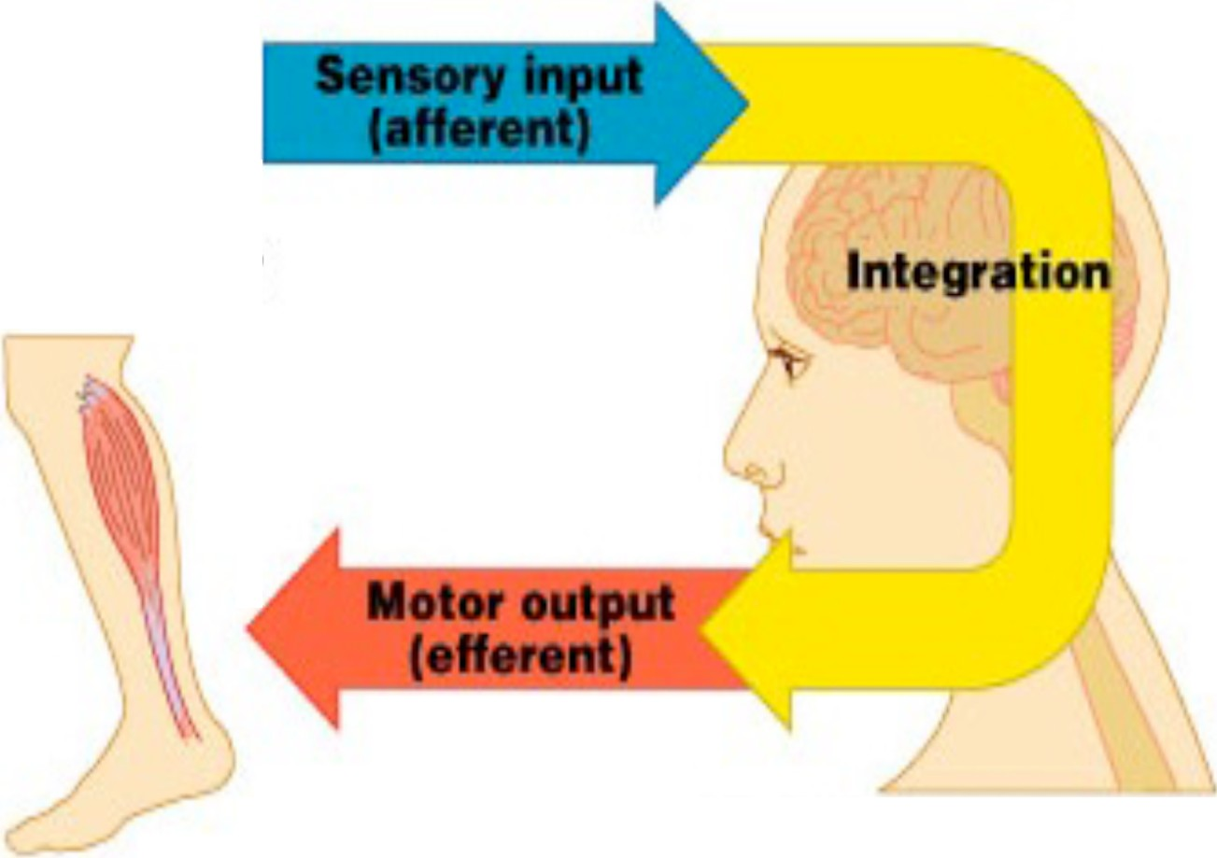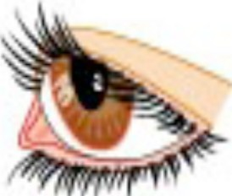Sensory receptor

Effector
Brain and spinal cord

- Neurons
  - Excitable nerve cells
  - Transmit electrical signals

- Supporting cells: neuroglia or just glia
  - Means “nerve glue”

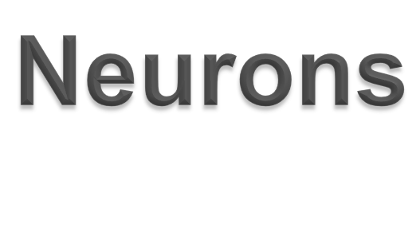
 Functional unit of nervous system
 Can live for a lifetime

 Do not divide
- (exception: neural stem cells )
- Cannot replace themselves

 High metabolic rate
- Require continuous oxygen and glucose
- Die within a few minutes without oxygen

 Processes and transmits information by electrical(ion channels & ion pumps) and chemical signaling (Synapse)

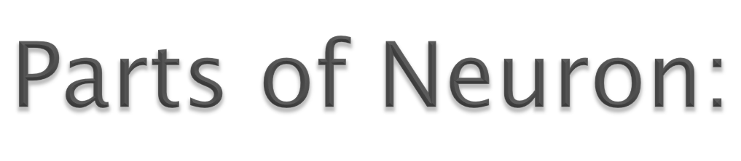

 Cell Body(soma)- usually compact
 Dendrites

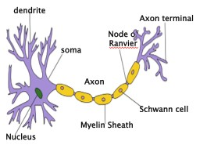 Axons
Extrude from soma

Dendrites (receptive regions)

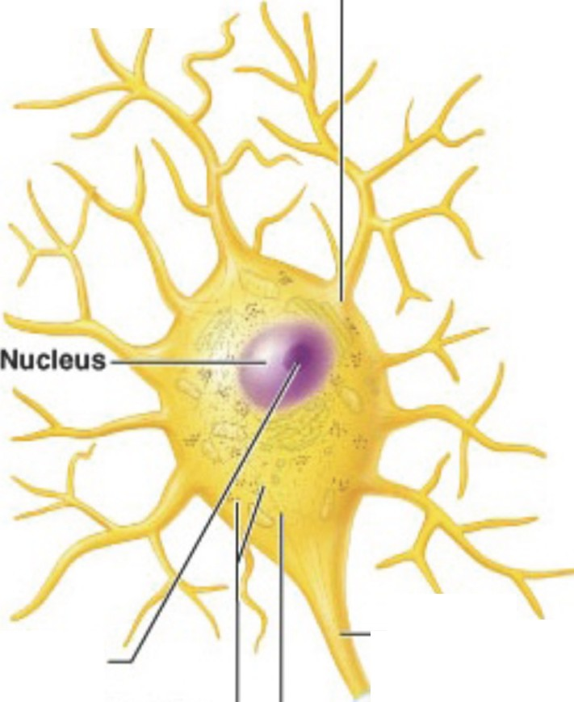A

Cell body (biosynthetic center and receptive region)

Nucleolus

Nissl bodies
--Axon
(Impulse generating and conducting
region)

Axon hillock

NeurUemma
._

Impulse direction• y
--
Schwann ceU
(one inter· node)

Node of Ranvler
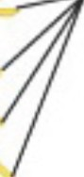I - Axonal tennlnals (secretory component)

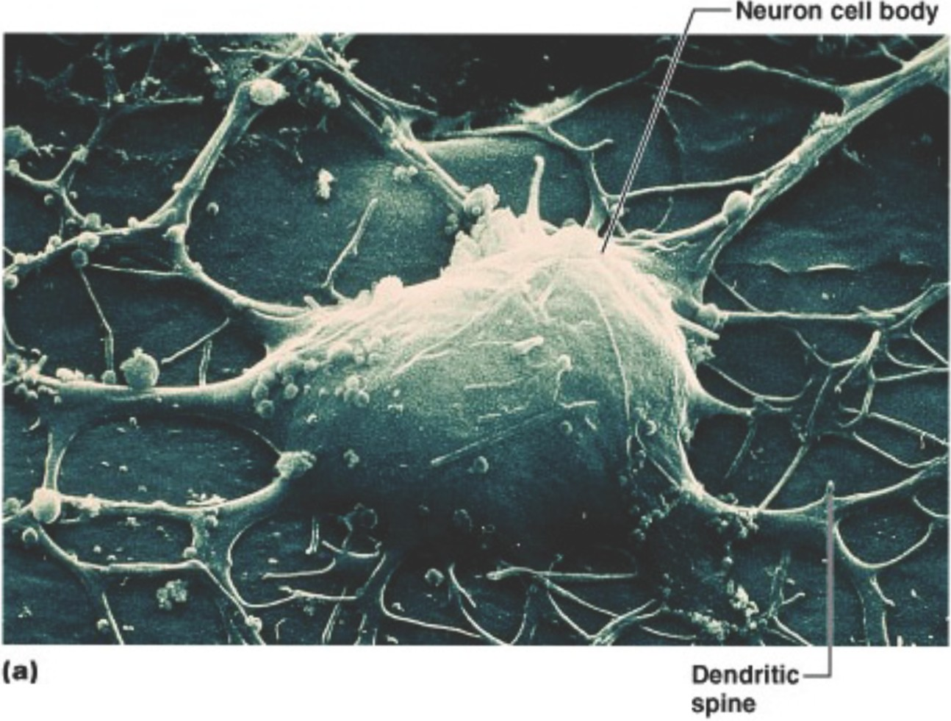
(bt
(sheath of
Schwann}

............
Terminal branches:_}_
(telodendria)

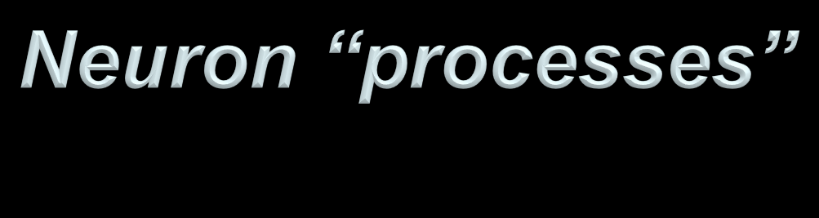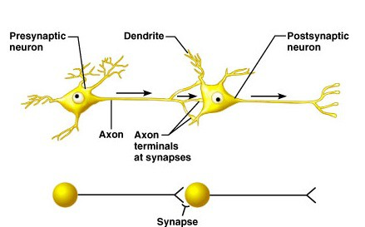

 Nerve fibers = Axons

- Arise from cell body at a site called ‘Axon Hillock’
- Nerve impulse generators & transmitters
- One per neuron, although can branch into “collaterals”
- May branch hundreds of times before it terminates
- At terminal end branch a lot
- can extend upto 1m in humans

 Receptive regions =dendrites
- Have receptors for neurotransmitters (chemicals released by other neurons)
- Neurons may have many
- Can extend for hundreds of micrometers
- Branch multiple times (get thinner at
each branching)

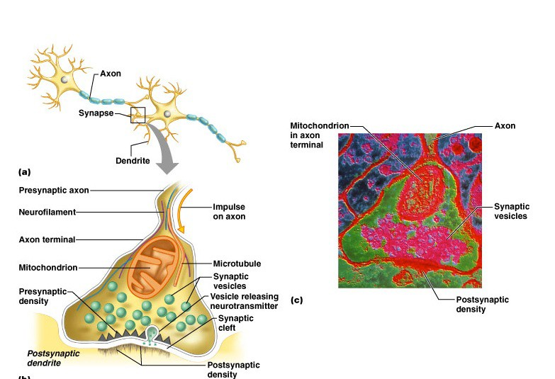Synapse-specialized connections with other cells

•Signals are sent from the Axon of one neuron to a Dendrite of another(generally)

ELECTRICAL ASPECT

•Depends on properties of the neuron’s membrane
•Includes
- ion channels- permit electrical charge ions to flow across
the membrane
- Can be voltage gated or chemically gated
- ion pumps-actively transport ions from one side of
membrane to the other

Interaction between ion channels & ion pumps

Voltage difference (Action Potential)
Power source for voltage dep. protein machinery embedded in the membrane

Basis for electrical transmission

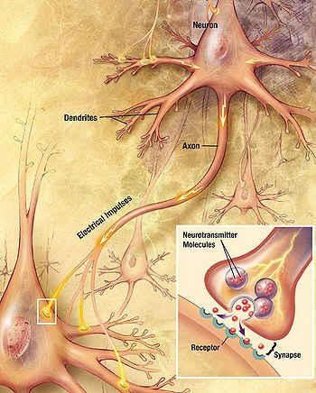CHEMICAL ASPECT

A propagating electrical signal traverse down the Axon to the Axon Terminals where neurotransmitter chemicals are released to communicate with target neurons
Contd.

Supporting cells = neuroglia (“nerve glue”)
or glial cells

- CNS
 |  | Astrocytes- Biochemical support of endothelial cells that form the blood brain barrier
 |  | Nutrients to nervous tissue
 |  | Maintenance of Extracellular ion balance
 |  | Repair & scarring process of brain & spinal cord following traumatic injuries
 |  | Oligodendrocytes- support and insulate Axons by creating a Myelin Sheath
 |  | Microglia- Macrophages
 |  | Acts as main form of Active Immune Defense in the CNS
 |  | Ependymal cells- thin epithelial membrane lining the ventricular system of brain & spinal cord
 |  | Involved in the production of CSF

- PNS
 Schwann cells
 Satellite cells

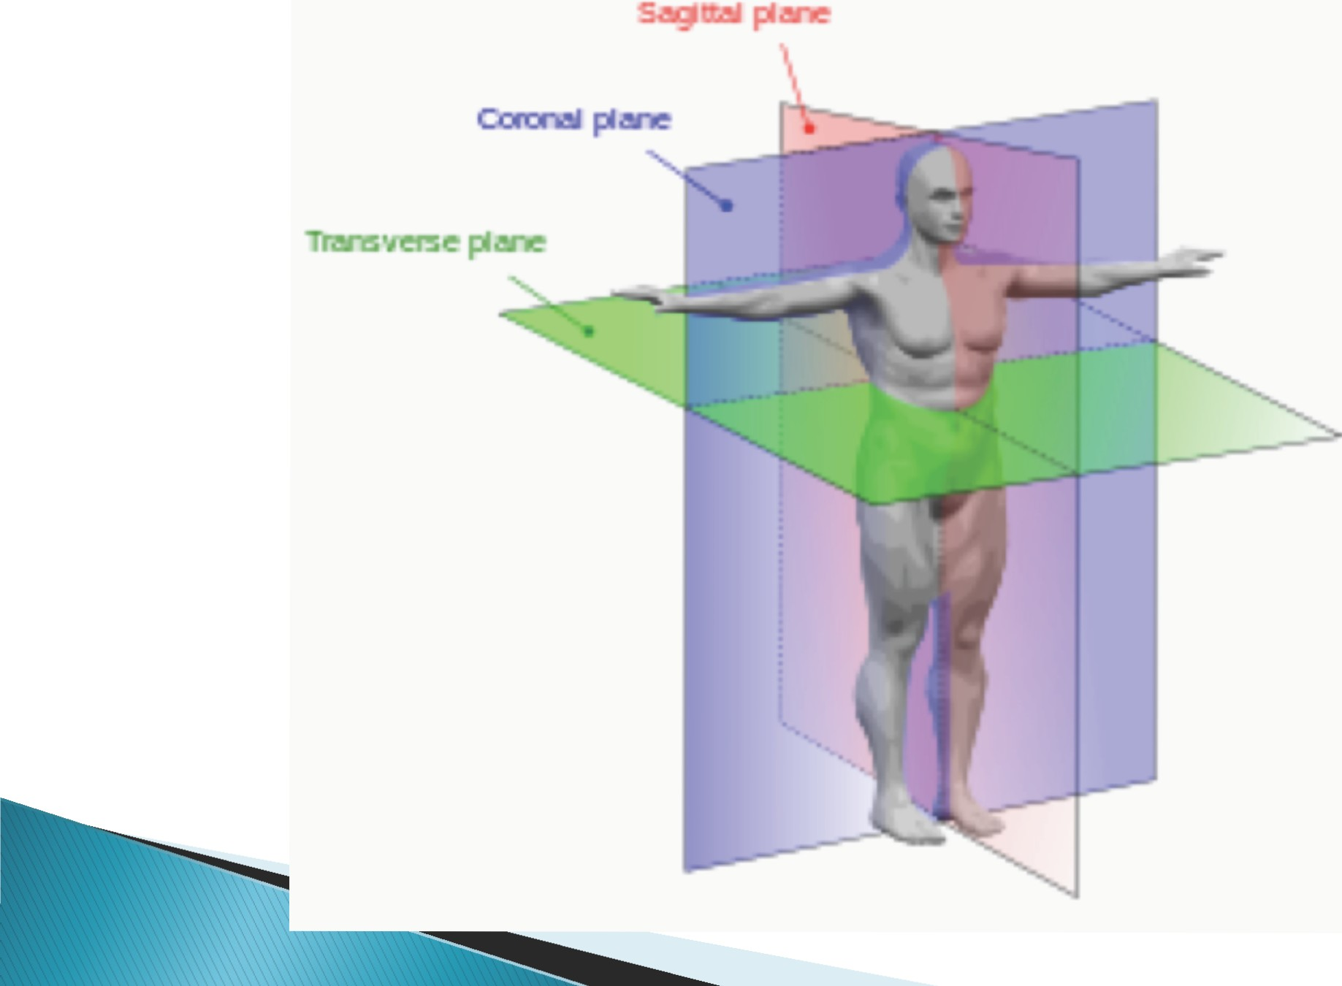Differ

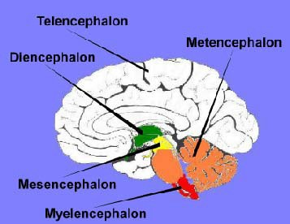

Telencephalon - Cerebrum - Largest division - divided into two Hemispheres - Includes Four lobes vi z F r o n t a l , P a r i e t a l , Temporal & Occipital Lobes

Diencephalon - Part of Forebrain
- I n c l u d e s T h a l a m u s ,
Hypothalamus & Pineal Gland

Mesencephalon- Midbrain

Metencephalon - Part of Hind brain - In clu des P on s & Cerebellum

Myelen ceph alon - P a r t o f Hindbrain- Includes Medulla Oblongata

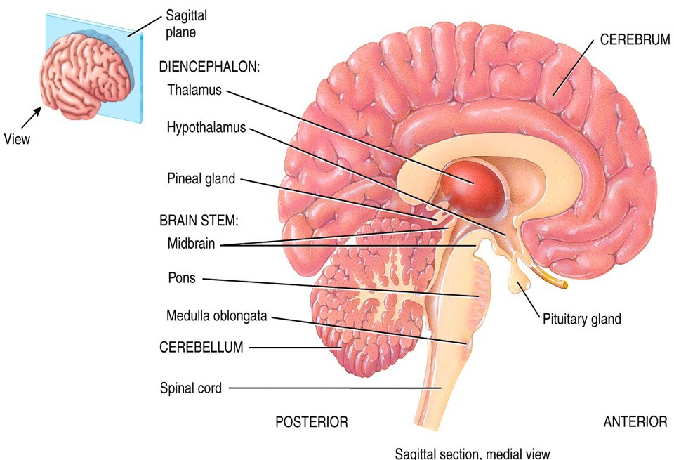

(Epiphysis)

(Hypophysis)

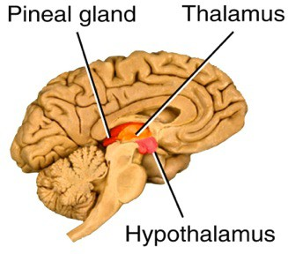DIENCEPHELON

THALAMUS-Midline paired symmetrical structure
•Largest part of Diencephalon & surrounds the Third Ventricle
•Situated between the cerebral cortex & midbrain
•Relays sensory & motor signals to the
cerebral cortex
•Regulates consciousness, sleep & alertness

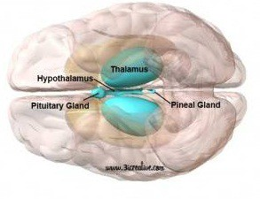HYPOTHALAMUS- Links the Nervous System to the Endocrine System via the Pituatory Gland
- synthesizes & secretes certain neuro hormones which stimulate or inhibit the secretion of Pituatory Hormones
•Controls body temperature, hunger, thirst,
fatigue, sleep & cicadian cycles

PINEAL GLAND-Produces Melatonin which affects the modulation of sleep/wake patterns, reproduction & circadian rhythm
•Activated by light, also called as THIRD EYE

Corpus Callosum

CNS

BRAIN
SPINAL CORD

FOREBRAIN
(Prosencephelon)
MIDBRAIN
(Mesencephelon)
HINDBRAIN
(Rhombencephelon)

DIENCEPHELON
CEREBRUM
(Telencephelon)

METENCEPHELON

MYELENCEPHELON

PONS CEREBELLUM
MEDULLA OBLONGATA

Telencephelon refers to the embryonic structure from which the mature Cerebrum develops
•Dorsal telencephelon (Pallium)-develops into cerebral cortex

•Ventral telencephelon (sub pallium)-becomes basal ganglia

KEY STRUCTURAL TERMS:

Gyri- series of folds

 Sulci- grooves between gyri

 Fissure- deep grooves

 Cerebral cortex- outer covering of Cerebrum. Also called Gray Matter. Gray because nuclei lack insulation
 White matter- Axons of multiple Neurons. Lies deep to the cortex
 Cerebral hemispheres

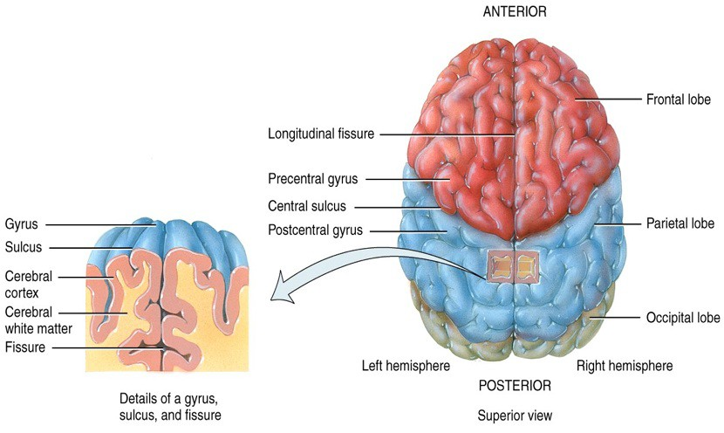The Cerebrum: Terminology

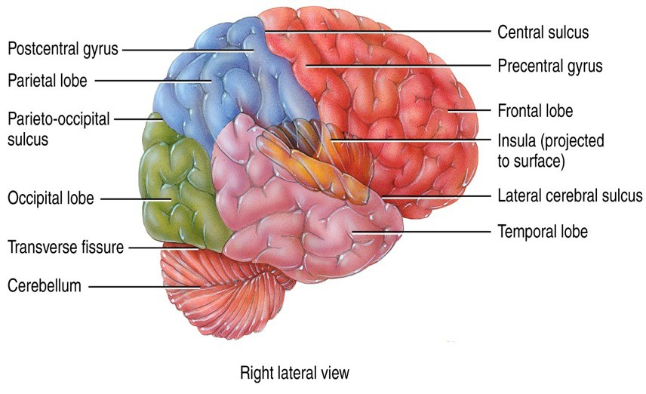LOBES OF THE CEREBRUM

LOBES OF THE CEREBRUM

- Each cerebral hemisphere has several regions known as lobes:

 Frontal lobe-Motor Lobe-produces body movements, contributes to personality, temperament, memory & intelligence

 Parietal lobe-Sensory Lobe-seeing, hearing, touching & smelling

 Occipital lobe-contains visual cortex, Responsible for Vision

 Temporal lobe-contains auditory cortex which affects hearing & interpretation of sound

 The insula (deep to temporal lobe)- may be involved in programming for speech sounds

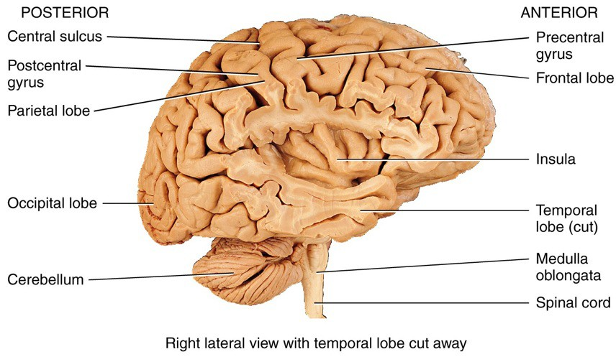LOBES OF THE CEREBRUM

CEREBRAL WHITE MATTER

- Most of the cerebral white matter consists of fiber tracts - major groups of axons connecting distant regions of cerebral neurons

 Association tracts connect gyri in the same hemisphere

 Commissural tracts connect areas in opposite hemispheres
  Corpus callosum

 Projection tracts connect the cerebrum to other brain regions
 Internal capsule

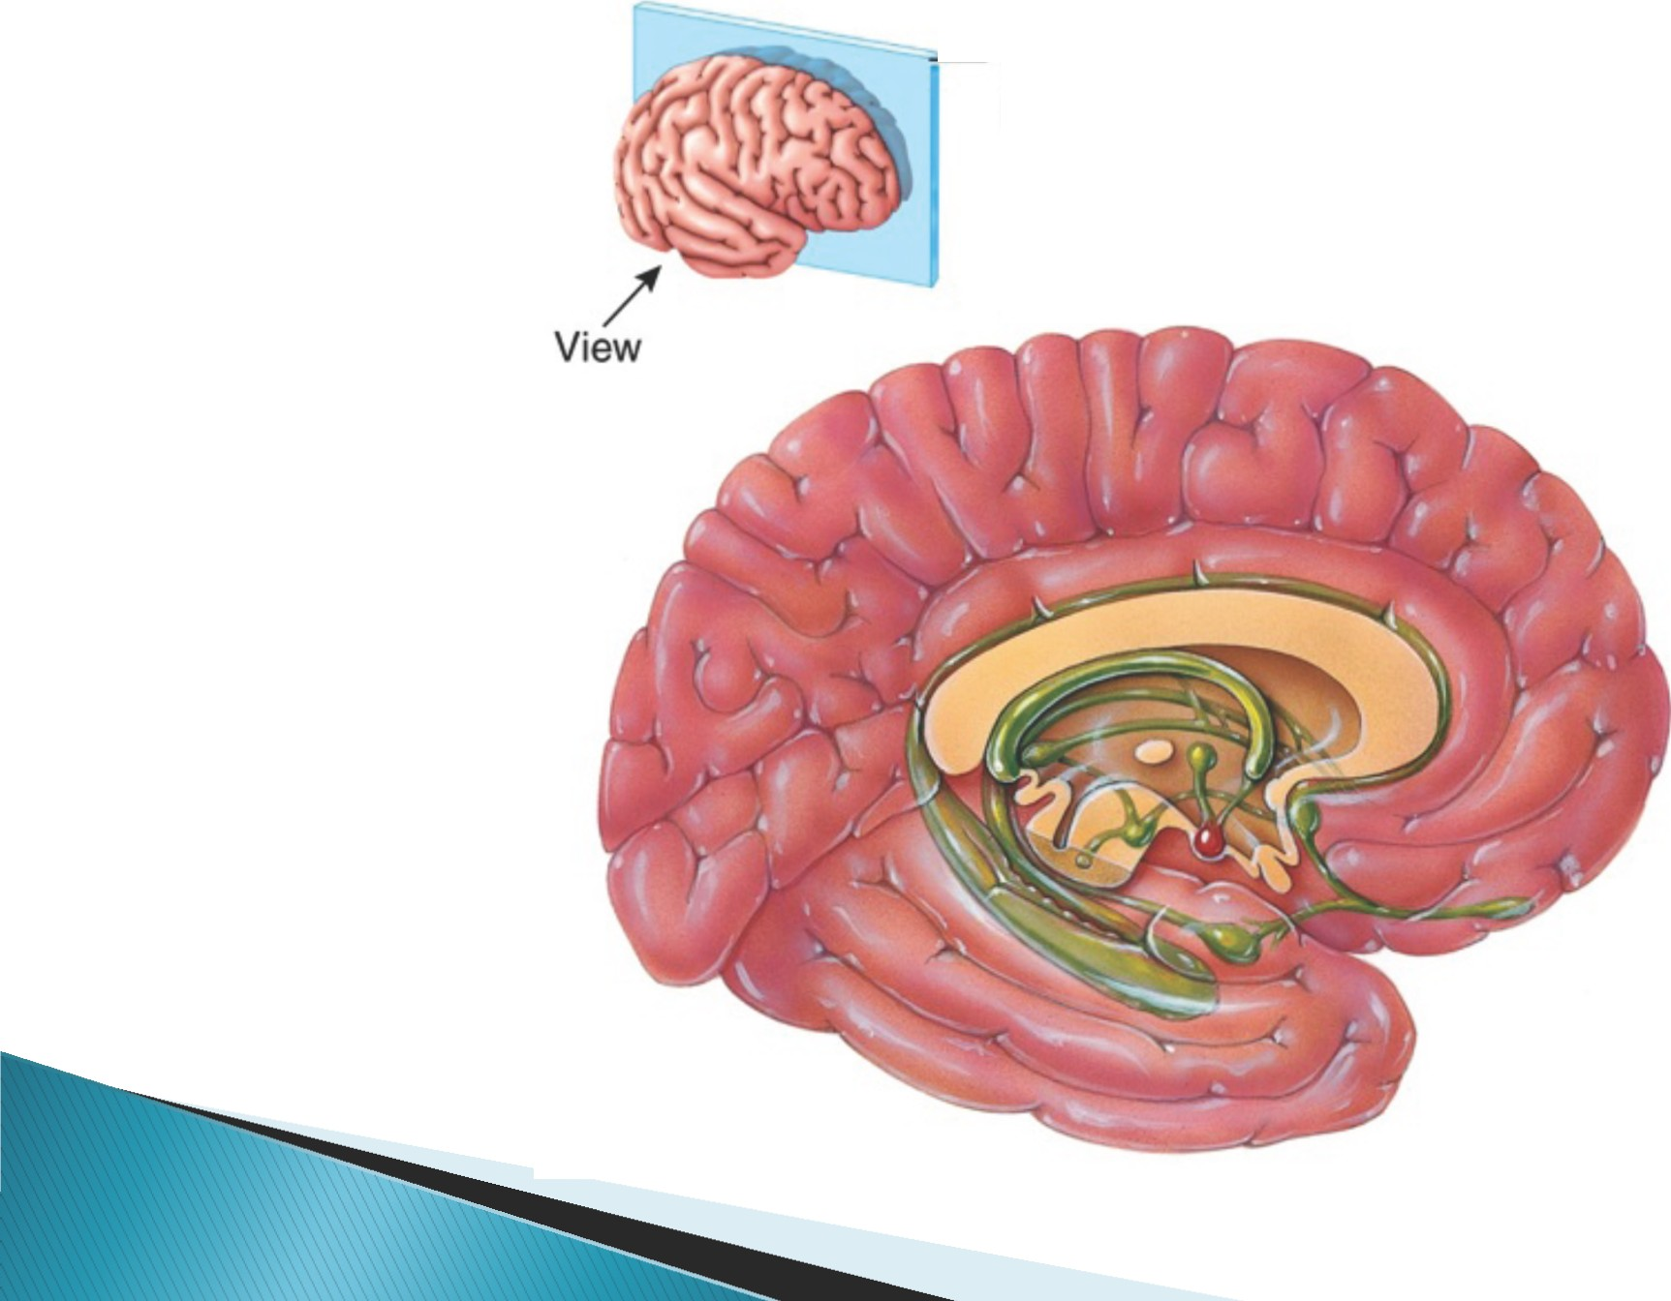The Cerebrum: The Limbic y tern

-Sagittal
plane

  - This ring-like set of structures (aka the “emotional brain”) lies along the border of the cerebrum and diencephelon

  - The limbic system mediates behaviors and emotions

 Pleasure and pain

 Fear/rage

 Affection

  - The limbic system also has a major role in memory &in controlling emotions, decisions, motivation & learning

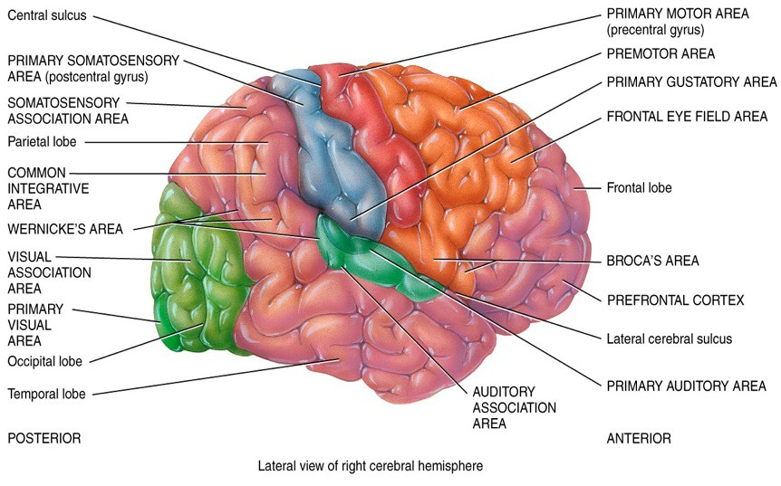

(Heschl’s Gyrus- sound first reahes here)

    - Regions of the cerebral cortex specialize in different types of information processing

 Sensory areas receive and process sensory impulses

 Motor areas initiate voluntary movements

 Association areas perform integrative functions

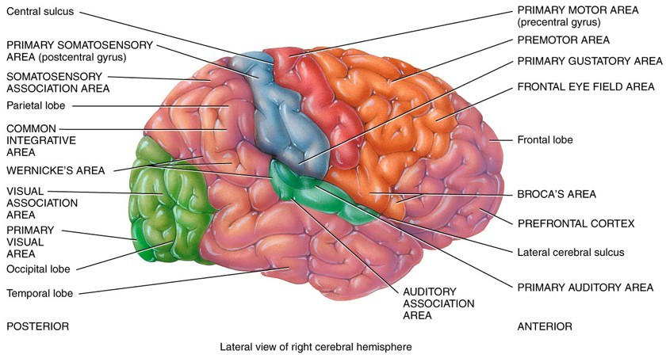

(Heschl’s Gyrus)

Sensory Areas of the Cerebrum

•Primary Sensory Area (postcentral gyrus)- receives sensory feedback from joints & tendons

•Presensory
•Secondary sensory
•Sensory Association Area

Located behind the postcentral gyrus. Capable of more detailed discrimination
&analysis

Information is first processed in the primary sensory area & is then sent to the secondary sensory areas

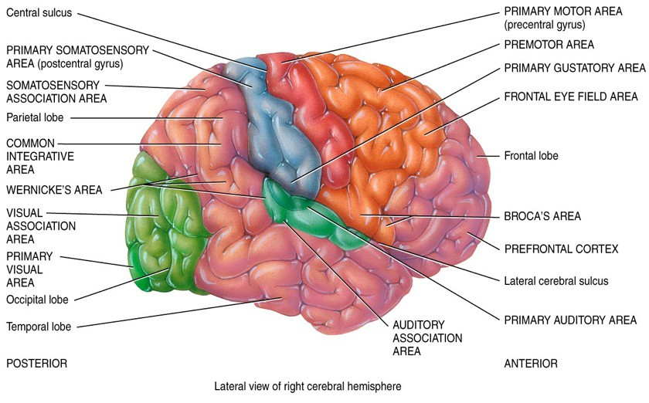

(Dominant for language)

(Heschl’s Gyrus)

- Major motor regions of the cerebral cortex include

 Primary motor area (precentral gyrus)- immediately anterior to the central sulcus. Controls the voluntary movements of Skeletal Muscles

 Premotor Area- immediately anterior to the Primary Motor Area. Responsible for the programming of motor movements (other than speech)

 Broca’s area- dominant for language. Found on inferior third frontal gyrus

Hemi pheric Lateralization of the Cerebral Cortex

TABLE 13.1 1
Functional Differences between the Two Cerebral Hemispheres
LEFT HEMISPHERE FUNCTIONS RIGHT HEMISPHERE FUNCTIONS

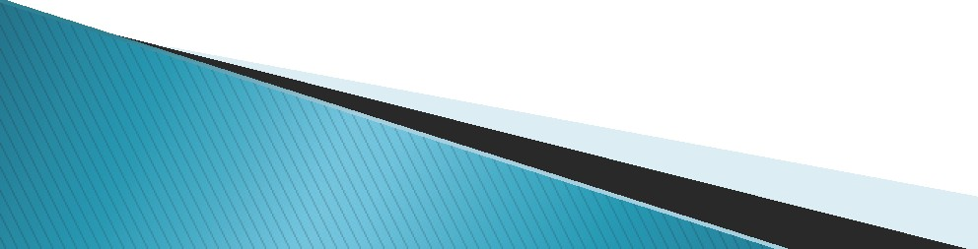
Receives somatic sensory ignals from and controls muscles on right ide of body.

Reasoning.

Numerical and scientific skills.

Ability to u e and under tand sign language. Spoken and written language .

Receives somatic sensory signals from and controls mu cle on left side of body.

Musical and artistic awareness. Space and pattern perception.
Recognition of faces and emotional content of facial expre ion .

Generating emotional content of language.

Generating mental images to compare patial relationships. Identifying and discriminating among odors .

BRAINSTEM: MIDBRAIN

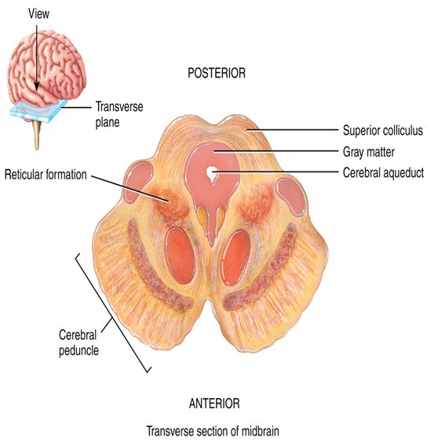•Relays motor impulses from the cerebral cortex to the pons and sensory impulses from the spinal cord to the thalamus

•Responsible for both Auditory
& Visual responses as well as
motor function
•Superior colliculi coordinate
movements of the head, eyes, and trunk in response to visual stimuli,
•inferior colliculi coordinate
movements of the head, eyes, and trunk in response to auditory stimuli. Contributes to control of movements

DIVISIONS OF THE HINDBRAIN

HINDBRAIN

Metencephelon
Myelencephelon

Pons Cerebellum
Medulla
Oblongata

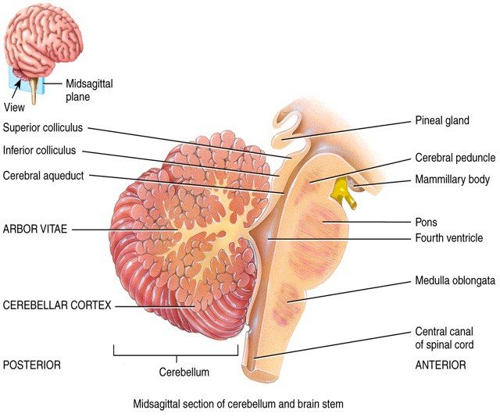BRAINSTEM: PONS

•Connects cerebral cortex
with Medulla Oblongata

•Serves as a communications
& coordin ation cen ter
b e t w e e n t h e t w o
Hemispheres

•Relays impulses between cerebral cortex an d cerebellum and between the medulla and midbrain

THE CEREBELLUM
10% of brain mass but contains almost 50% of all brain neurons

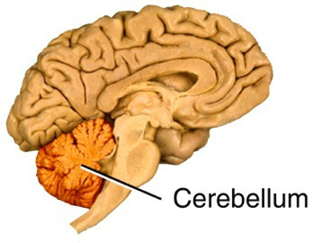 The cerebellum is critical to coordinated mo ve me nt s , a n d p r o v i d e s c o n s t a n t feedback to motor areas

•controls motor movement coordination, balance, equilibrium & muscle tone

•Relays information between body muscles
& areas of cerebral cortex that are involved
in motor control

•Compares intended movements with what is actually happening to smooth and coordinate complex, skilled movements

•Regulates posture and balance

- May have a role in cognition and language processing.

The cerebellum - second largest area of the brain.
  - muscle coordination, walking,and speech.
  - Symptoms of lesion in the cerebellum

include

swaying, difficulty with coordination and walking, and difficulty with speech.

The Cerebellum: Internal

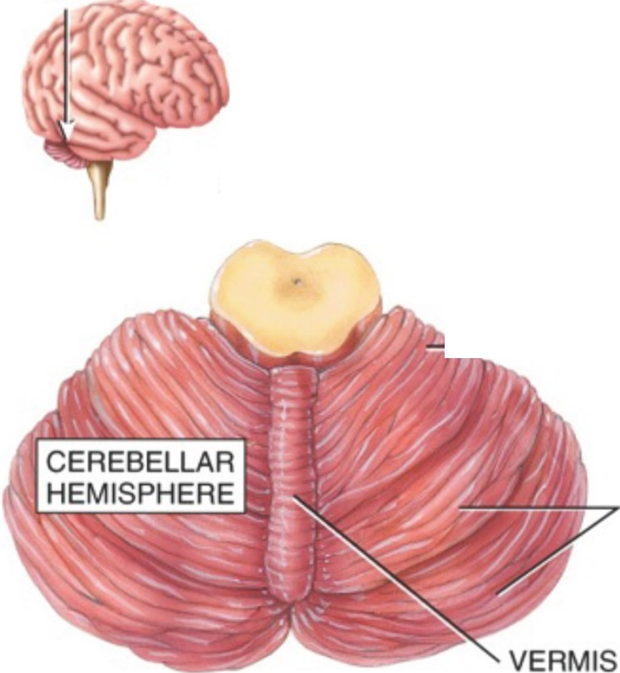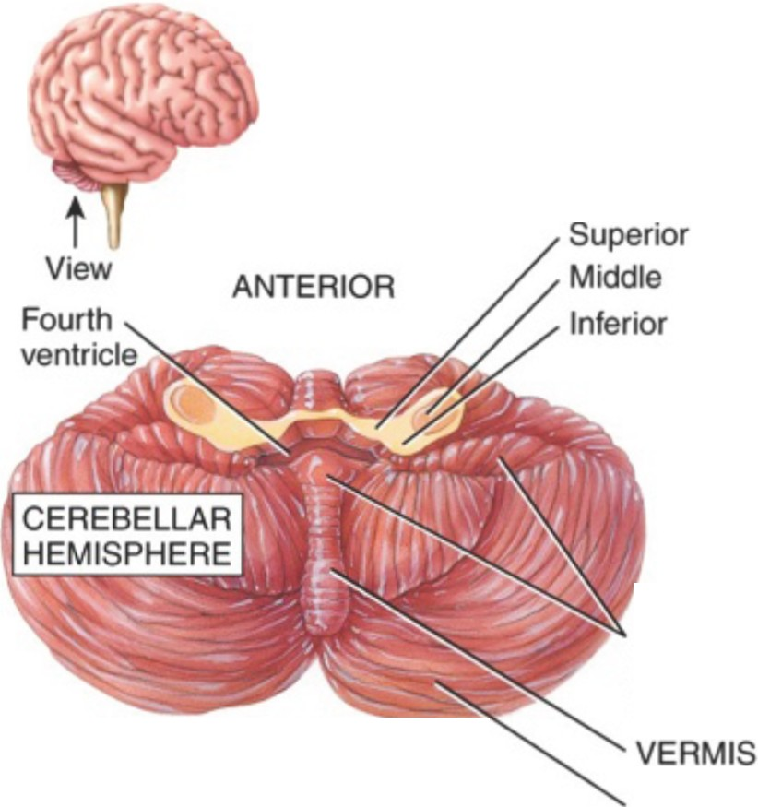View

ANTERIOR

---ANTERIOR
LOBE

POSTERIOR (MIDDLE) LOBE

tructure

CEREBELLAR PEDUNCLES:

FLOCCULO­ NODULAR LOBE

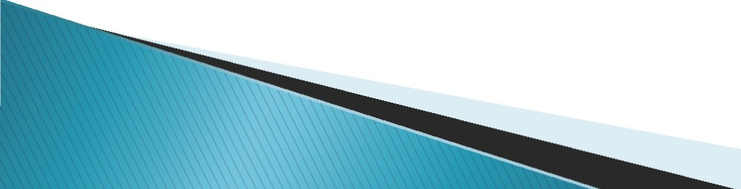POSTERIOR

  - Superior view
POSTERIOR

  - Inferior view

POSTERIOR LOBE

MEDULLA OBLONGATA

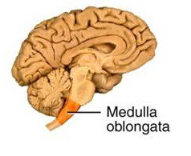•Large fiber tracts in the medulla connect the spinal cord to the brain

•Relays motor and sensory impulses between other parts of the brain and the spinal cord

•The medulla includes control centers for respiration, heart rate, blood pressure, and other functions (e.g., cou g h in g , v om itin g , sw allow in g , sneezing etc.)

•Vital centers regulate heartbeat, breath in g (tog eth er w ith pneumotaxic and apneustic area of pons), and blood vessel diameter

• Other centers coord inate swallowing, vomiting, coughing, sneezing, and hiccuping.

RETICULAR FORMATION
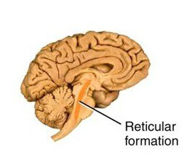

Helps maintain consciousness, causes awakening from sleep, filters repetitive sensory input, and contributes to regulation of muscle tone

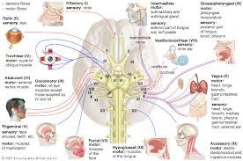

 The CNS is protected by

◦ | Bone
 |  Cranial bones protect the brain & support the face
 |  Vertebrae protect the spinal cord
◦ | Three meninges (layers of connective tissue surrounding CNS) | the

- Cerebrospinal fluid (CSF) - the CNS is cushioned by a thin layer of fluid

Protection of the CN - cranial bones

View
Frontal bone

Hypophyseal fossa of sella turcica

Frontal sinus Crista galli

Squamous suture
Lambdoid suture -;...,_..

TEMPORAL BONE

Internal auditory -- -..:
meatus

External occipital ---­
protuberance

Hypoglossal canal

Occipital condyle Styloid process Pterygoid processes Mandibular foramen

PALATINE BONE

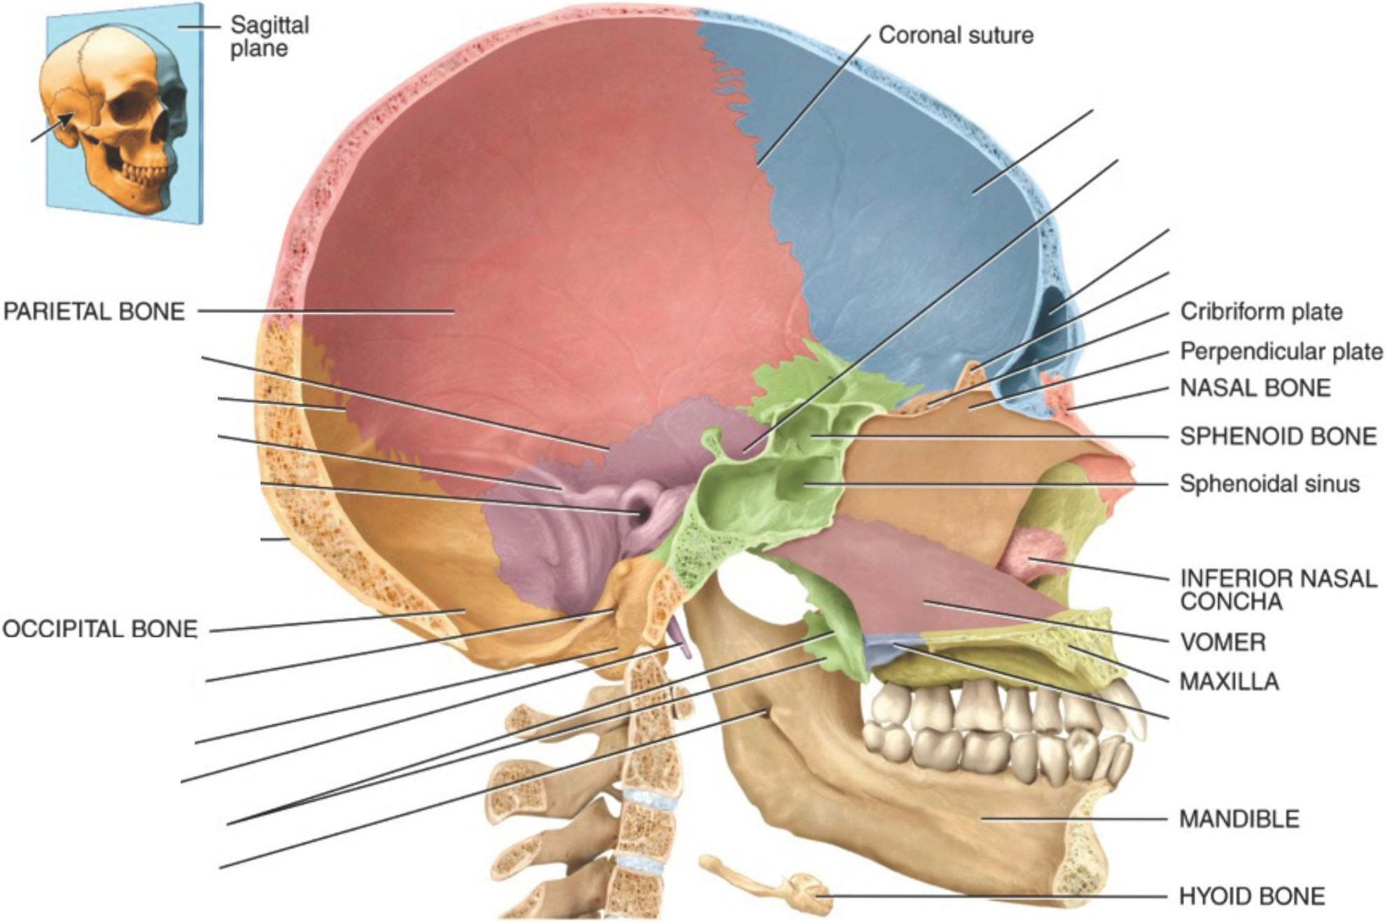Medial view of sagittal section

Protection of the CN
Vertebrae

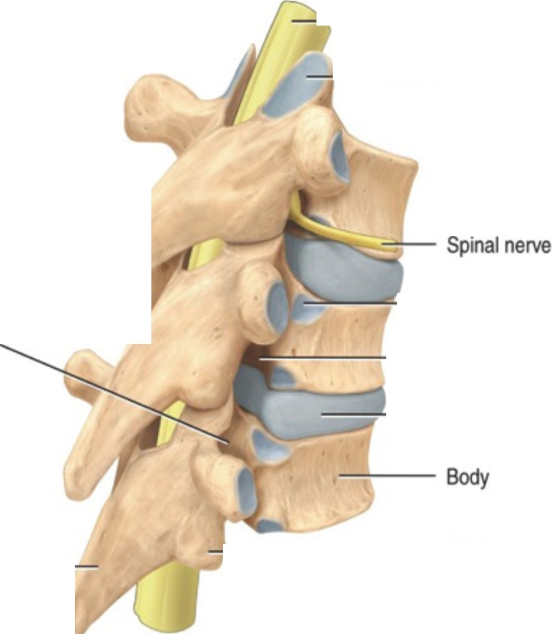POSTERIOR
;;....

ANTERIOR
Spinal cord

Facet of superior
POSTERIOR -------- Facet of superior

Spinous Transverse

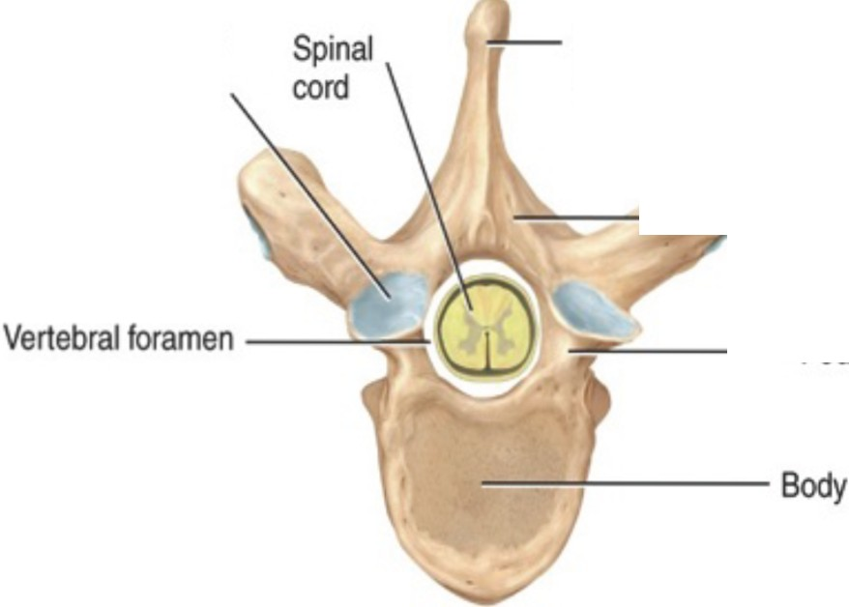articular process
I

articular process
process process

/ Vertebral arch:

' Lamina

::::;..... Pedicle

--lllC...- Facet for head
of rib

....:....._ ,:._
lntervertebral
foramen

==------ lntervertebral disc

ANTERIOR

    - Superior view

Spinou1c-s -­ process

------- Inferior articular
process

    - Right posterolateral view of articulated vertebrae

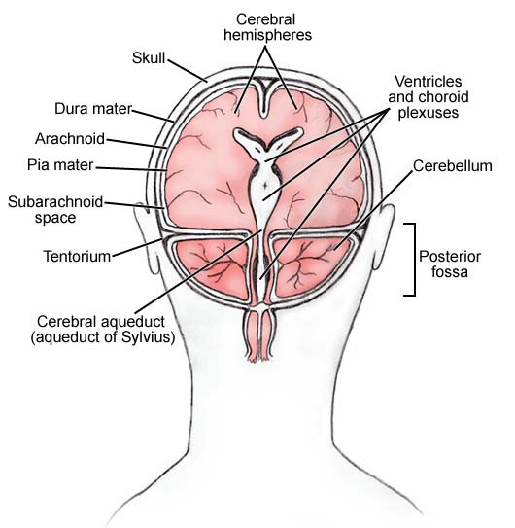

  - Dura mater
 Epidural space- space between dura m a t e r & surrounding bone of the vertebrae
 Dural sinuses

 Subdural Space- space between Duramater & Arachnoid Mater

  - Arachnoid mater
 Subarachnoid space-
space between arachnoid mater
& piamater

  - Pia mater

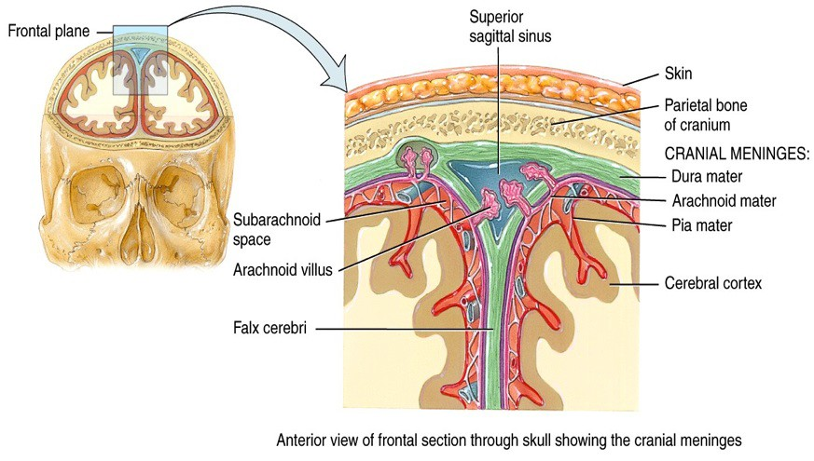
Fold of dura mater, descends vertically in the Longitudinal Fissure between the cerebral hemispheres
(Gray matter)

 The meninges also surround the spinal cord, and the cranial and spinal meninges form a single unified protective covering for the CNS.

 Blood supply to the brain is a crucial source of O2 and nutrients

 The brain receives much greater blood supply than expected based on its size and mass

 Blood flow to active areas of the brain increases during higher levels of metabolic activity

 Interruptions in blood flow have very serious consequences (unconsciousness, stroke, death)

 Cerebrospinal fluid (CSF) is a nutrient-rich fluid that circulates within and around the CNS

 CSF serves three key homeostatic functions in the CNS

    - Mechanical protection

    - Chemical protection

    - Circulation

VENTRICLES OF THE BRAIN

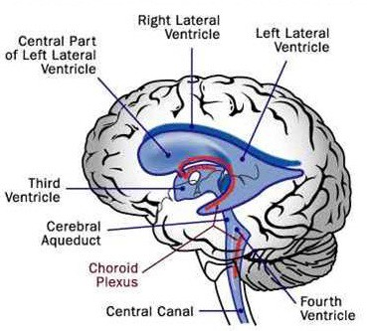

(Produce CSF)
Ventricles are the communicating cavities (containing CSF) within the brain that are continuous with the central canal of the spinal cord

LATERAL VENTRICLES-
•curved shaped cavities
•Largest of the ventricles
•Protects the brain from Trauma & provides pathway for the circulation of CSF

THIRD VENTRICLE
•Narrow cavity located in the middle of the Cerebral Hemispheres between the
right and left thalamus
•Connected to the Fourth Ventricle via the Cerebral Aqueduct

FOURTH VENTRICLE
•Runs between the Pons, the Medulla Oblongata and the Cerebellum
•Extends from the Cerebral Aqueduct to the Obex (Point at which fourth
Ventricle narrows to become the central canal of the Spinal Cord) & is filled with
CSF

•CSF entering the Fourth Ventricle through Cerebral Aqueduct can exit to subarachnoid space through Foramen of Luschka & a single midline Foramen of Magendie

Cerebro pinal Fluid

FOURTH VENTRICLE LATERAL APERTURE
- LATERAL VENTRICLES

- 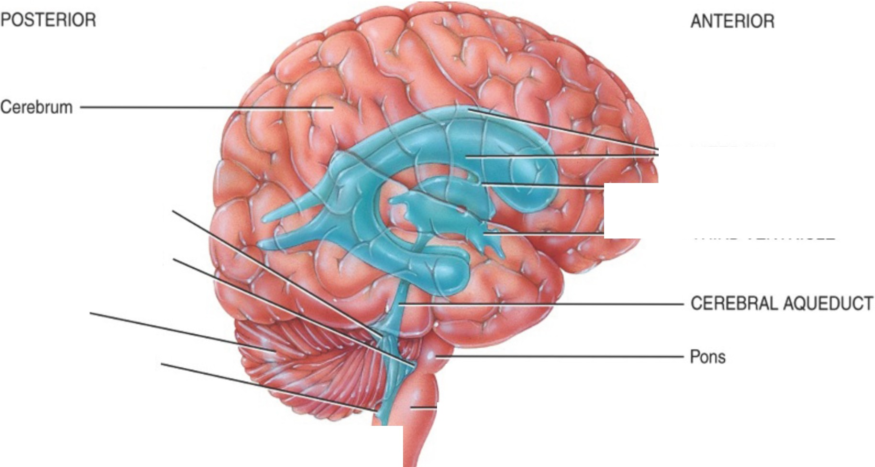INTERVENTRICULAR FORAMEN

- THIRD VENTRICLE

Cerebellum

MEDIAN APERTURE

---------Medulla oblongata

CENTRAL CANAL ---------

---------Spinal cord

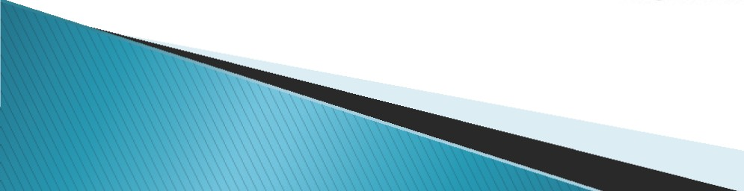

Right lateral view of brain

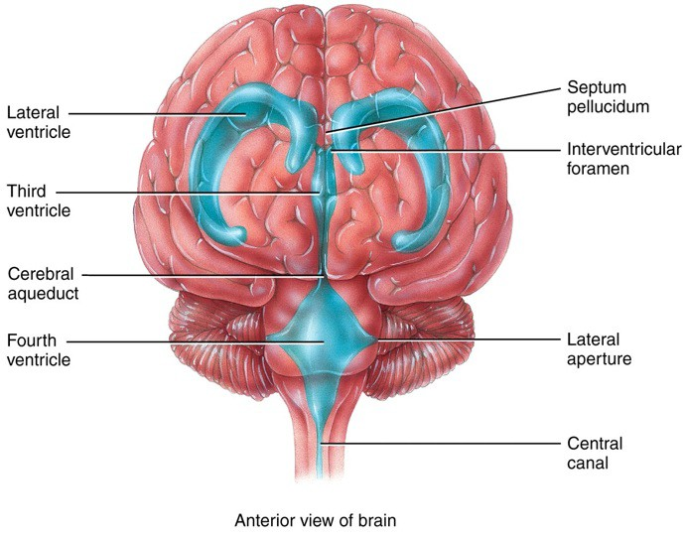

(Foramen of Monro)

(Foramen of Luschka)

Circulation Pattern of C F

POSTERIOR ANTERIOR

CHOROID PLEXUS OF
LATERAL VENTRICLE
CHOROID PLEXUS OF THIRD VENTRICLE
Cervbrum ------:r,:'.;,£'.:_
lnterm ,.t• m•u
or t lomuis

-ARACHNOID VILLUS

.._..,,..,,.... SUBARACHNOID SPACE

-SUPERIOR SAGITTAL SINUS
- -!-;-- Corpoa cellosum

INTERVCNTRICULAR FORAMC'.N

Cerebellum

THIRD VENTRICLE

CHOROID PLEXUS Of" FOURTH VENTRICLE
MEDIAN APERTURE FOURTH VCNTRICl.E

JI·+of----- Spln.,1 oord
-lit--<------ CCNTRAL CANAL
Crflnl{IJ moning«ts
Pllll m ter Amehno6d meter Dure meter

Path o4

..cs

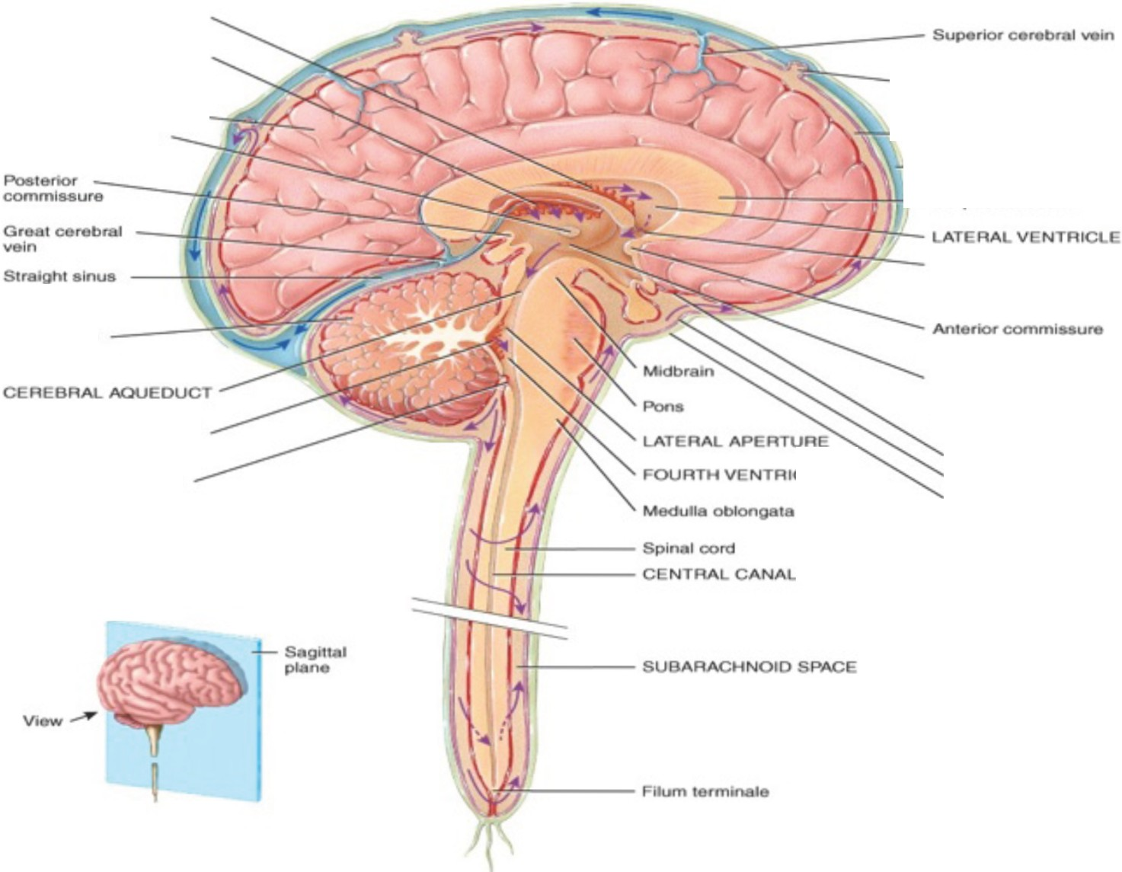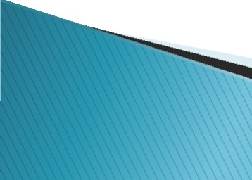--- venous blood

Sagittal aect>on ol brain end 11p.nal con:!

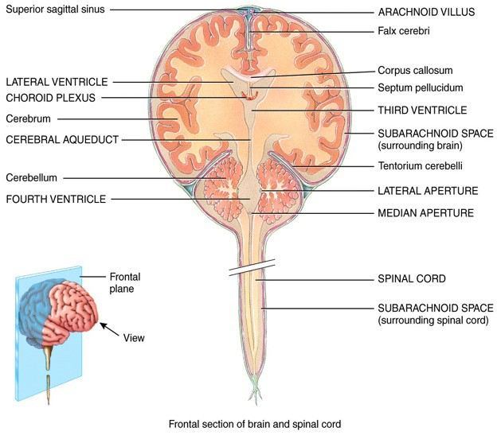

(Connect the two hemispheres

(Foramen of Luschka) (Foramen of Magendie)

---------------------

