**IMAGE-GUIDANCE SYSTEM**

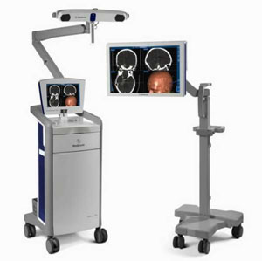

***Image Guidance System (Stealth Station from Medtronic)***

**Image-guided surgery** (IGS) is the general term used for any [surgical](http://en.wikipedia.org/wiki/Surgery) procedure where the [surgeon](http://en.wikipedia.org/wiki/Surgeon) employs tracked surgical instruments in conjunction with preoperative or intraoperative images (3D) in order to indirectly guide the procedure. Furthermore, the images can be changed, manipulated and merged to provide a level of detail not seen before in the operating room. The technology is similar to that used by today’s *Global Positioning Satellite* (GPS) systems, which can track the exact location and direction of vehicles at any point on the globe. Because the view is so precise and so controllable, a surgeon can actually see where healthy tissue ends and a brain tumor begin.

Most image-guided surgical procedures are [*minimally invasive*](http://en.wikipedia.org/wiki/Minimally_invasive)*.*

Image-guided surgery has been employed in neurosurgery since the mid-1990s. This new technique relies on a powerful computer system, which assists the surgeon in precisely localizing a lesion, in planning each step of the procedure via a 3D model on the computer screen, and in calculating the ideal access to the tumor before the operation. The tumor and its surroundings can be viewed from different angles and in relation to landmark structures, such as the optic nerve or the brain stem. During the operating procedure, the movement of the instruments in use inside the brain can be tracked on the monitor with a precision of 1-2 millimeters, through which damage to healthy tissue and to critical areas can be avoided as much as possible.

The technology was originally developed for treatment of brain [tumors](http://en.wikipedia.org/wiki/Tumors), but has found widest application when applied to surgery of the [sinuses](http://en.wikipedia.org/wiki/Paranasal_sinus), where image-guided surgery helps avoid damage to brain and nervous system.

**X-RAYS V/S IMAGE GUIDANCE**

While conventional x-ray images depict tumors in two dimensions, Image Guidance System provides the third dimension - depth - creating a three-dimensional image of the head and brain. This is particularly useful in reaching a tumor located deep within brain areas traditionally considered to be difficult to reach.

**NEED**

Before the advent of this technology, surgeons would have to study two-dimensional diagnostic scans, such as X-rays, and then determine how those images corresponded to the patient’s actual body.

The brain is the most complicated structure in the universe, making it necessary to approach surgery carefully and with extreme planning to minimize the risk to patients.

Image-guided surgery has revolutionized traditional surgical techniques by providing surgeons with a way to navigate through the body using three-dimensional (3D) images as their guide that can help ensure the safety of vital structures, while providing the best outcome for patients.

**PRINCIPLE**

Depends on the registration of pre-operatively acquired images with the physical space of the patient on the operating table and to keep the imaged data as long as possible, in its original digital format while transferring it to the computer dedicated to the OR (Operating Room) to provide a direct interaction with the data.

**WORKING-** The system works by analyzing pre-operative diagnostic scans of the patient — usually CT images or MRI

1. Prior to an image-guided operation, the patient undergoes diagnostic testing such as a CT (computed tomography) scan or MRI (magnetic resonance imaging).
2. The imaging data set is transferred via optical disk, CD-ROM, or computer network to the operating room, where it is loaded into the workstation. The images are brought up on the image-guided surgery (IGS) system prior to the procedure and checked for image quality and accuracy.
3. Once loaded into the (workstation) system, advanced computer technology translates this information into precise 3D images that help surgeons map the safest, least invasive path to the target site in the patient’s body.
4. **Next, the system assists the surgeon in the operating suite, where it produces three-dimensional, real-time images of the procedure in progress**- When surgery begins, the 3D images are synchronized with real-time information provided by light emitting diode (LED) cameras within the operating room. By matching the pre-surgery information to the patient’s real anatomy, surgeons can manipulate the view to see precisely what they need to see. It also allows them to track instruments during the surgery, including the position of the instrument and the angle at which it is entering the body — side to side, up and down and back and forth — with tremendous precision.
5. The modern systems can even merge images from multiple sources and manipulate the pictures, allowing physicians to view them from any angle. In effect, surgeons literally “see” behind delicate or hard-to-reach areas of the patient’s unique anatomy without disturbing the surrounding tissue.

**STAGES**

1. ACQUISITION- A set of medical images (MRI or CT) are acquired of the relevant portion of the patient’s anatomy.

Also called as **Image Guidance Scan**

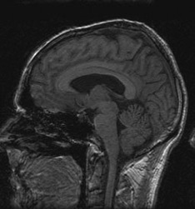

***Image Guidance Scan***

Prior to the Image Guided Operation, the patient undergoes diagnostic testing such as CT Scan or MRI.

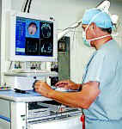

***The patient's MR or CT images are viewed on the computer monitor, and the surgeon develops a treatment plan.***

The imaging Data Set is transferred via Optical Disk, CD-ROM or Computer Network to the OR where it is loaded into the workstation (CT or MR images of the surgical field are imported into the computer software).

DATA SETS- Multiple pictures of human body, including X-Rays, CT scan and MRI. These images can be merged using Image Guidance Technology to create one extremely detailed image that provides surgeon with more data than any single imaging technique

1. SEGMENTATION-The images are segmented into distinct anatomical structures, yielding a 3-D patient specific model.

Once loaded into the workstation, advanced computer technology translates this information into precise 3-D images that helps surgeon map the safest, least invasive path to the target site in the patient’s body.

1. REGISTRATION- The model is registered to the actual position of the patient on the operating table, enabling Augmented Reality Visualization.

Done by the fiducials with a special instrument

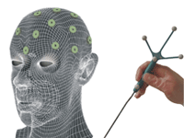 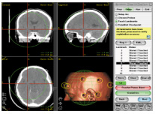

***Registration by touching the Fiducials with a probe having retro-reflective spheres attached***

Fiducials are the skin markers that are registered using a probe linked to the computer by a camera which detects the probe’s position in space. This matches the position of head in space with the images in the computer.

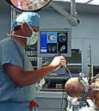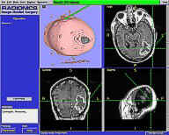

***Matching of position of head in space with the images in the computer***

Once the registration is complete and accurate, the computer can show the relationship of the surgical instruments to the imaged brain and the surgeon can work in the mathematical space (coordinate system) of the brain image that is same as physical space under optimum conditions

This process allows the surgeon to track his surgical instruments during surgery- position of the instrument and the angle at which it is entering the body - A digitizing camera senses the position of the surgeon's instruments (via a probe) in space and indicates the position of the instrument on the image displayed on the computer monitor in real time as the operation proceeds

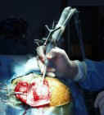

***Tracking of surgical instruments during surgery***

1. TRACKING- Surgical instruments are tracked relative to the patient and the model, allowing the surgeon to effectively execute procedures, while avoiding hidden, critical structures**.**

There are four types of tracking systems:

1. **Mechanical systems**- Frame-based navigational systems-

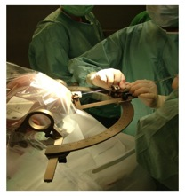

***Head Frame Fixation***

These are the most traditional guidance option (also known as stereotaxy) and have the advantage of being extremely accurate because a rigid head frame is fixed to the skull. Disadvantages include patient discomfort during frame placement, time taken to calculate the trajectory, and inability to project or image where the biopsy probe is. In fact it is a “blind” procedure via a small burr hole without having control over the stereotactic pathway and any complications (bleeding or missing the preplanned aim) during the surgery

1. **Ultrasonic systems-**

They determine position by measuring the time of flight of sound from an emitter (piezoelectric component or spark emitter) to at least three microphones. By comparing the time needed for the sound to arrive at each microphone, the position of the sound emitter can be determined. The accuracy of sonic digitizers is dependent on the speed of sound remaining constant. Because the speed of sound varies with temperature, humidity, air constitution, drafts and noise, gradients of these variables between the array and probe result in positional error. Those factors are always present in the operating room and are a major point of concern although they can be detected and partially corrected by using a control emitter at a known distance. Additionally, sonic detectors are sensitive to echoes from the operating room walls and the floor. Absolute accuracy with standard systems is poor, typically +/- 5 mm.

1. **Electromagnetic systems**-

These systems employ electromagnetic field arrays that use as reference points a device attached to the patient's head (a plastic mask with metallic beads or headband) and a wired instrument that the surgeon uses within the target site. Electromagnetic systems do not have to be "seen" by the computer. Excess metal within the electromagnetic field can cause inaccuracies.

They superimpose a magnetic field upon the operative field. Position can be determined by introducing a probe that can detect gradients in the magnetic field. An advantage of magnetic digitizers in comparison to sonic and optical digitizers is that they do not require an unobstructed path from the emitters to the detector array which is crucial for sonic and optic digitizers. A major drawback with these devices is the need for a precise magnetic field in order to maintain accuracy. Ferromagnetic substances, aluminum, and electromagnetic radiation distort magnetic fields, and impair localization accuracy

1. **Optical systems**

These systems use infrared sensors in combination with light-emitting diodes or passive reflectors that are fixed to the patients head (e.g., via a headband strap or sticker) and fixed to a handheld probe. Both the headband and the instrument must be simultaneously "seen" by the computer in order to track where the surgeon's instrument is within the sinuses.

Intraoperative digitization through an infrared system is based upon a *three-dimensional motion analysis system*. Real-time localization is achieved by an opto-electronic system consisting of light-emitting diodes (LED) on a digitizer and an array of charge coupled detector (CCD) cameras that detect the position of the light-emitting diodes. The use of multiple cameras is a well-known ***triangulation technique*** for three-dimensional acquisition of position coordinates. Infrared light is frequently used for

* maximal accuracy
* decreased sensitivity to ambient light
* minimal emitter size

although stray infrared light in the operating room can cause problems.

Optical technology probably offers the greatest potential in terms of:

* accuracy
* speed of acquisition

at the expense of slightly more complex components.

The goal of optical measurement technologies is to calculate the exact pose (position and orientation) of a tool, object or person within a pre-defined coordinate system. Optical motion-trackers typically use multiple two-dimensional imaging sensors (cameras) to detect "active" infrared-emitting or "passive" retro-reflective markers affixed to some interaction device. Based on the information received from multiple cameras, the system is able to calculate the location of every marker through geometric triangulation. When more than two markers are grouped together to form a rigid-body target, it becomes possible to determine the target's orientation, yielding a total of six degrees of freedom (6-DOF).

**COMPONENTS OF OPTICAL TRACKING SYSTEM**

1. A **powerful computer system**, which assists the surgeon in precisely localizing a lesion, in planning each step of the procedure via a 3D model on the computer screen, and in calculating the ideal access to the tumor before the operation



***Computer System/ Workstation***

1. **Optical Imaging System**- measure the 3D positions of either active or passive markers affixed to application-specific tools. Using this information, each Polaris System is able to determine the position and orientation of tools within a specific [measurement volume](http://www.ndigital.com/medical/polarisfamily-techspecs.php#measurementvolume).

Polaris Spectra

***Optical Camera with inbuilt IR strobe***

* can be equipped with an optional integrated positioning laser
* Laser assists in aligning the position sensor with the area of interest

1. A **hand-held surgical probe** whose position is tracked by the IGS and the anatomy beneath it is displayed as, for example, three orthogonal image slices on a workstation-based 3D imaging system. Existing IGS systems use different tracking techniques including mechanical, optical, ultrasonic, and electromagnetic

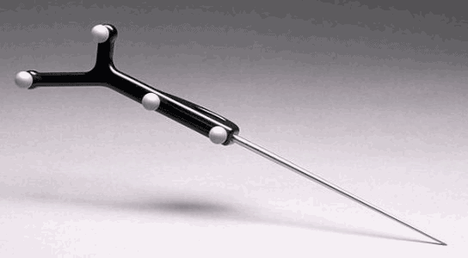

***Probe with retro-reflective spheres***

**TECHNOLOGY BEHIND OPTICAL TRACKING**

1. The coating reflects most of the IR by the camera’s built in LED Strobe back to the imaging sensor

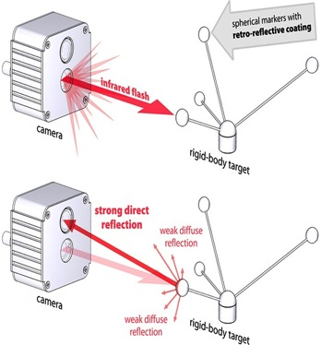

1. The software runs advanced image processing to calculate the projected centers of every marker in every camera image

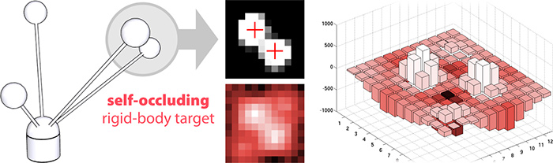

1. The 3D location of every marker is recovered by geometric triangulation

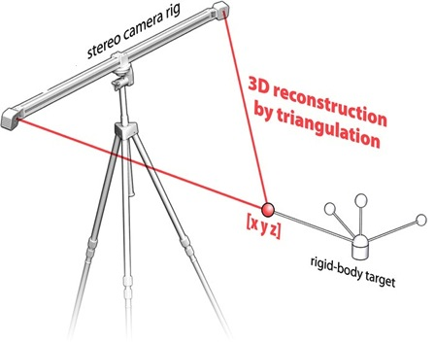

1. The software identifies pre-calibrated rigid body targets and computes their position and orientation (6-DOF Pose)

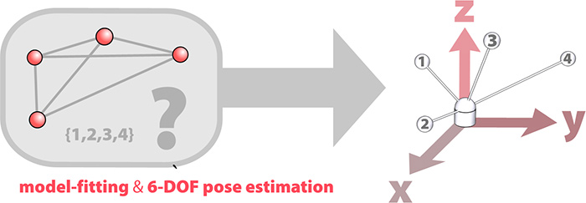

**APPLICATIONS**

* Stereotactic Biopsy
* Craniotomy
* Shunts
* Implants
* Functional Neurosurgery
* Tumor biopsies
* Visualization of critical brain structures
* Tumor resection

**ADVANTAGES:**

1. Because of the precision that image-guided surgery technology provides, surgeons are able to create an exact, detailed plan for the surgery — where the best spot is to make the incision, the optimal path to the targeted area, and what critical structures must be avoided.
2. The technology allows surgeons to view the human body — a dynamic, three-dimensional structure itself — in real-time 3D.
3. The technology creates images that allow surgeons to see the abnormality, such as a brain tumor, and distinguish it from surrounding healthy tissue. It also enables them to manipulate the 3D view in real-time during surgery.
4. The constant flow of information helps surgeons make minute adjustments to ensure they are treating the exact areas they need to treat.
5. Help Surgeons know the precise anatomy
6. Help identify important landmarks during surgery

**BENEFITS TO THE PATIENT**

1. shortening operating times,
2. decreasing the size of the patient’s incision,
3. reducing the procedure’s invasiveness

leading to better patient outcomes and recoveries

**DRAWBACKs** of this technology became apparent right from the beginning of its implementation in neurosurgical operations:

1. All these neuronavigational systems use images, mainly CT or MRI pictures, acquired preoperatively, on which the planning of the operative procedure as well as its intraoperative performance is based. They, therefore, have several potential sources of error. (exposure to extra dose of radiation in case of CT**/** can be claustrophobic for patients in case of MRI)
2. Registration (using skin markers or anatomical landmarks) may be inaccurate mostly because of scalp movement, geometrical distortion in the images, and movement of the patient with respect to the system during surgery.
3. Another relevant source of inaccuracy is the so-called brain shift (movement of the brain relative to the cranium between the time of scanning and the time of surgery).
4. Computer systems are susceptible to human error

Due to these sources of error, the usefulness of surgical navigation may diminish during the surgical procedure.

As dynamic changes of the surgical field regularly occur during the surgical procedure, the surgeon is faced with a continuously changing intraoperative field for which the preoperative data does not provide any information.

It is clear that only intraoperatively acquired images will provide the neurosurgeon with the online information he needs to perform real intraoperative image-guided surgery. A number of ***high-tech tools*** for use during neurosurgical procedures have been developed in recent years, like intraoperative navigated ultrasound and dedicated moveable intraoperative CT units. However, MRI currently is and definitely will be in the future the superior imaging method for intraoperative image guidance.



IGSTK is a software package oriented to facilitate the development of image guided surgery applications

It is an OPEN SOURCE software toolkit designed to enable researchers to rapidly prototype and create new applications for image guided surgery

Provides functionalities that are commonly needed when implementing image guided surgery applications, such as integration with optical and electromagnetic trackers, manipulation and visualization of datasets

The cornerstone of IGSTK is robustness

**CONCLUSION**

The term "image-guidance" refers to the use of a probe that is tracked by a machine as that probe moves through the target site. A computer, which is either physically or remotely attached to that probe, provides the surgeon with a map of the target tissues. This map is provided by a CT scan or/and MRI, which is performed prior to your surgery. This CT scan or MRI is commonly referred to as a "image-guidance scan."

In some respects, image-guidance is similar to a GPS system, constantly calculating the position of the probe within a patient's bodyand displaying that location on a "3-dimensional" layout of the sinuses provided by the patient's own CAT scan or MRI. Unlike GPS systems in your car, image-guidance tools don't tell surgeons where they can go, rather, it gives them a very precise knowledge of where they are.

The key step for the use of neuronavigational systems is the generation of 3D preoperative image data merged with the patient’s anatomy by registration.

Once registration is accurate, the surgeon can work in the mathematical space (cartesian coordinate system) of the brain image that is the same as physical space under optimum conditions. The need for image guidance during neurosurgical operations has always been a concern for neurosurgeons and has evolved through several steps over the last 60 years.

With the combination of digital technology and localizing systems, patient’s preoperative imaging can be correlated with the patient’s position intraoperatively. Thus, a Neurosurgeon is able to preoperatively plan and transfer this plan to the patient’s head precisely, and is able to visualize the patient’s intracranial anatomy both before and during surgery.

Unlike earlier forms of image-guided surgery, the recent systems incorporates standard surgical instruments. Images of the instruments are seamlessly rendered within the images of the patient’s anatomy, allowing the surgeon to see the exact location of the instruments, in 3D and in real time, on the monitor. This allows surgeons to track instruments during the surgery, including the position of the instrument and the angle at which it is entering the body — side to side, up and down and back and forth — with tremendous precision.

Frameless neuronavigational systems in contrast to frame-based devices track the movement of surgical instruments in space by ***optical, ultrasonic, or electromagnetic sensors***. Their relative position to the lesion can be projected from preoperative imaging but not in an intraoperative real-time modus. The rapid development of navigational devices has provided the neurosurgeon with an unprecedented degree of surgical accuracy and precision for the planning as well as performance of a large variety of neurosurgical procedures. In this context, the development of image-guided neurosurgery represents a substantial improvement in the microsurgical treatment of tumors, vascular malformations, and other intracranial lesions.